# Vintage Car Auction Database Project Documentation

June 07, 2024

Prepared by Fedor Rushkevich

## 1. Overall Description

This document provides comprehensive documentation for the Vintage Car Auction database project. It includes detailed descriptions of the database schema, main functions and procedures, and step-by-step instructions for running scripts and loading data. The purpose of this project is to manage and analyze data related to vintage car auctions, including information about cars, auctions, bidders, bids, auction houses, car ownerships, and payments.

## 2. Schema Details

#### 2.1 OLTP Schema

**The OLTP (Online Transaction Processing) schema consists of the following tables:**

- AuctionHouses

- Auctions

- Cars

- Bidders

- Bids

- CarOwners

- CarOwnership

- Payments

**AuctionHouses Table**

Columns:

- AuctionHouseID (INT, Primary Key)

- Name (VARCHAR(100))

- Location (VARCHAR(100))

**Cars Table**

Columns:

- CarID (INT, Primary Key)

- Make (VARCHAR(50))

- Model (VARCHAR(50))

- Year (INT)

- VIN (VARCHAR(17))

- Condition (VARCHAR(50))

# Schema :

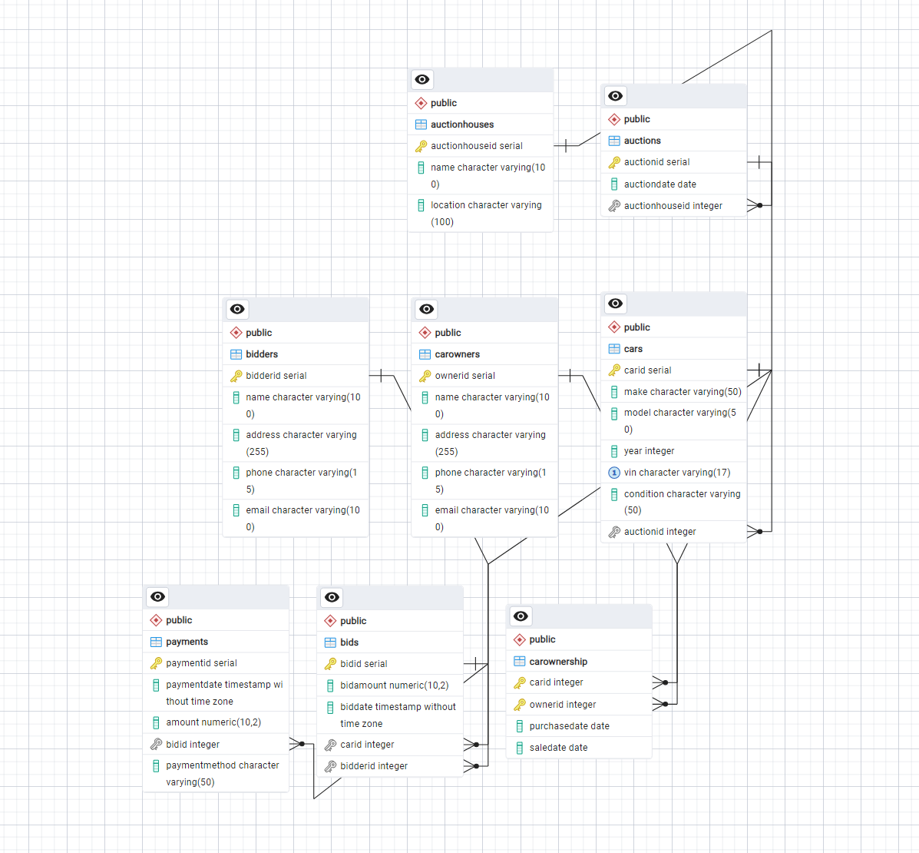

#### 2.2 OLAP Schema

**The OLAP (Online Analytical Processing) schema consists of the following tables:**

- Dim_AuctionHouses_SCD

- Dim_Cars

- Dim_Bidders

- Dim_Date

- Dim_CarOwners

- Dim_CarOwnerships

- Dim_Payments

- Fact_Auctions

- Fact_Bids

**Dim_AuctionHouses_SCD Table**

Columns:

- SurrogateKey (SERIAL, Primary Key)

- AuctionHouseID (INT)

- Name (VARCHAR(100))

- Location (VARCHAR(100))

**Fact_Auctions Table**

Columns:

- FactAuctionID (SERIAL, Primary Key)

- AuctionID (INT)

- DateID (INT)

- AuctionHouseKey (INT)

- TotalSales (DECIMAL(15, 2))

- NumberOfCars (INT)

# 

# Schema:

#### 1)

#### 2)

## 3. Functions and Procedures

**This section describes the main functions and procedures used in the Vintage Car Auction database project.**

CalculateTotalSales

Purpose: Calculate the total sales for an auction.

CREATE OR REPLACE FUNCTION CalculateTotalSales(AuctionID INT) RETURNS DECIMAL AS $$

BEGIN

RETURN (

SELECT SUM(BidAmount)

FROM Bids

WHERE AuctionID = $1

);

END;

$$ LANGUAGE plpgsql;

## 

## 4. Steps Taken to Achieve Results

This section outlines the steps taken to design, develop, and implement the Vintage Car Auction database project.

#### 4.1 Designing the ER Diagram

An Entity-Relationship (ER) diagram was created to represent the main entities and relationships in the Vintage Car Auction application. The main entities include Cars, Auctions, Bidders, Bids, and Auction Houses. The ER diagram ensured normalization principles were followed.

#### 4.2 Developing the OLTP Solution

The OLTP database schema was created in PostgreSQL, including logical and physical designs. Tables, indexes, queries, functions, procedures, and triggers were defined to ensure the database adhered to the 3rd Normal Form (3NF).

#### 4.3 Preparing Data for OLTP Database

Realistic datasets were generated for each entity (Cars, Auctions, Bidders, Bids) and saved as separate CSV files. Data quality, consistency, and format were ensured for proper database integration.

#### 4.4 Creating Data Load Script

A script was developed to load data from CSV files into the OLTP database using PostgreSQL. The script included logic to check for existing data and load only new entries.

#### 4.5 Developing the OLAP Solution

A snowflake schema was designed for the data warehouse, including at least 2 fact tables (Fact_Auctions, Fact_Bids) and 1 Slowly Changing Dimension (SCD) Type 2 (Auction Houses). Logical and physical schemas, tables, and indexes were defined.

#### 5.6 Developing the ETL Process

An ETL process was created to transfer data from the OLTP database to the OLAP database. The ETL script ensured rerunability without overwriting previously loaded data, including steps for extracting, transforming, and loading data.

#### 5.7 Creating Visual Reports in Power BI

Power BI reports were developed based on the OLAP solution. The reports included titles, filters, and visual components to answer analytical questions regarding auction results, bidder locations, and bid trends.

# Result :

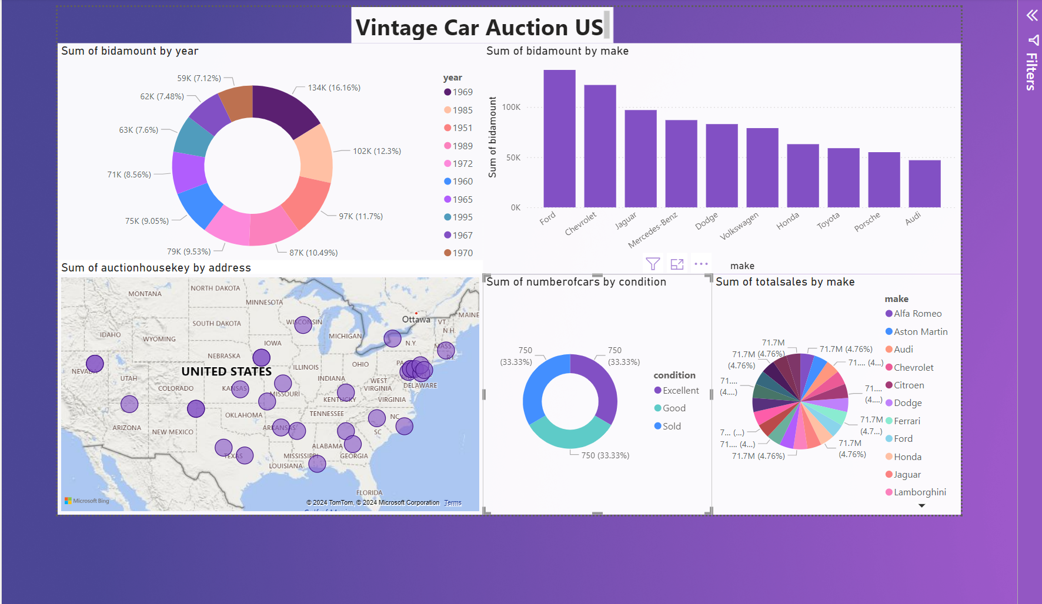

#### In case of any questions:

Fedor Rushkevich

fedrushkevich@gmail.com